**ASSIGNMENT SUBMISSIONS**

NAME: S.Mudassir Hussain

COLLEGE NAME: SMK FOMRA INSTITUTE OF TECHNOLOGY

TEAM MEMBER 02:

1. Create a blog or website using Blogspot and WordPress. Customize the theme design and post new article with 500 words.

BLOG LINK:

<https://novamerchs.blogspot.com/2023/10/elevate-your-style-with-nova.html>

1. Create a New Facebook Business Page and post one social media poster for your brand.

FACEBOOK PAGE LINK:

<https://www.facebook.com/people/Nova-Merch/pfbid0k9MnBPGe35hBk5RPZumR3rmy44tzopBos6DnZbXbRsZeiCr4mS1z9193BfrgLJBql/?sk=about>

1. Create and design a social media advertisement poster using canva.

SOCIAL MEDIA ADVERTISEMENT POSTER:

1. Create email newsletter design using MailChimp or canva tool.

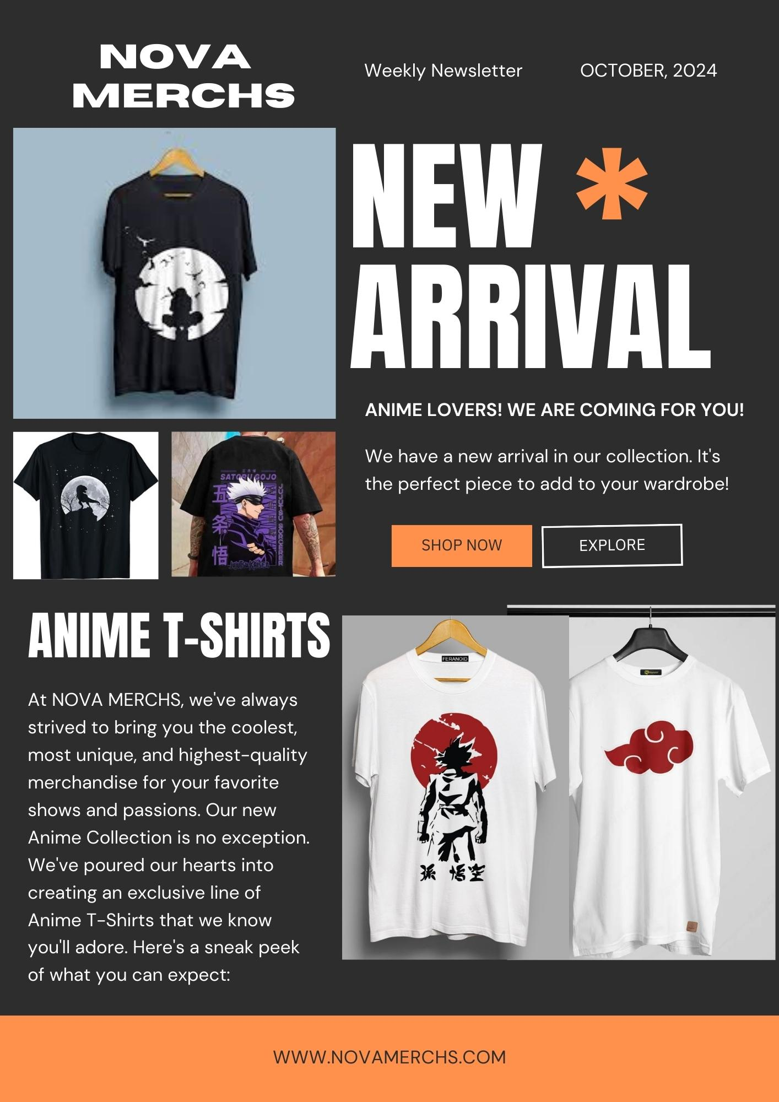EMAIL NEWSLETTER:

